|  |  |
| --- | --- |
| **Name:** | **Dhuware Chaitanya Rakesh** |
| **Roll Number:** | **20IM10009** |

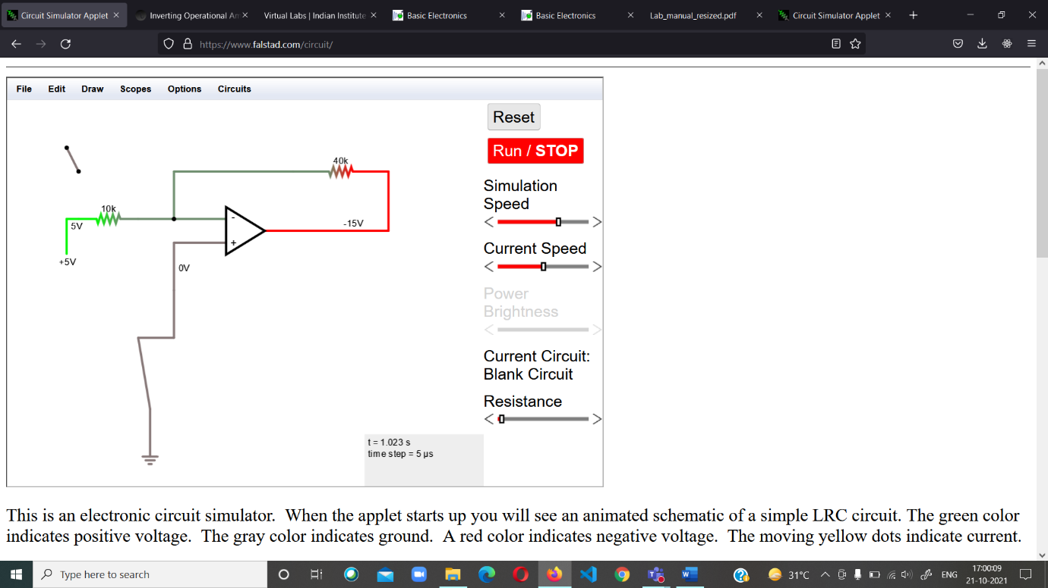**ASSSIGNMENT 5 OP- AMP**

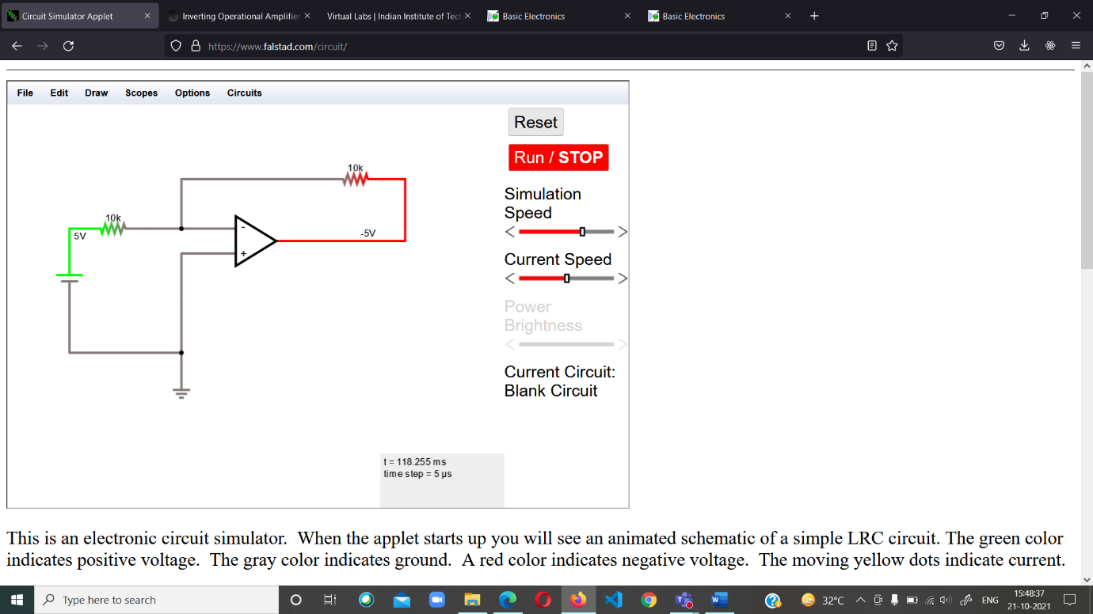

DC GAIN

DC GAIN

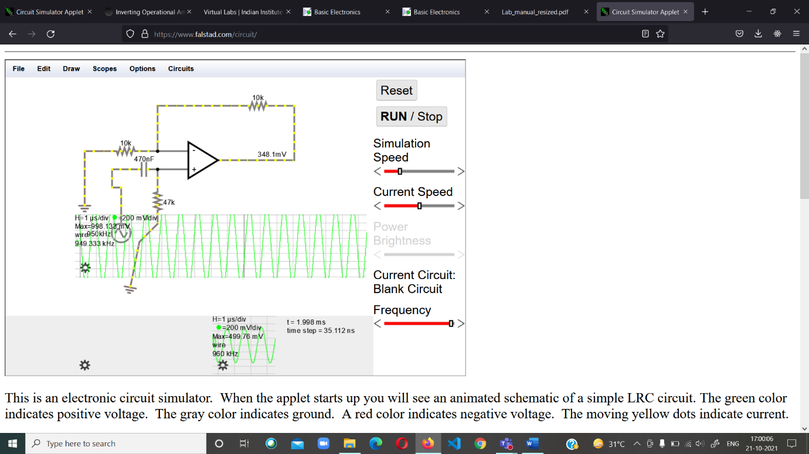

NON INVERTING OP AMP

ADDER DC OFFSET

ADDER

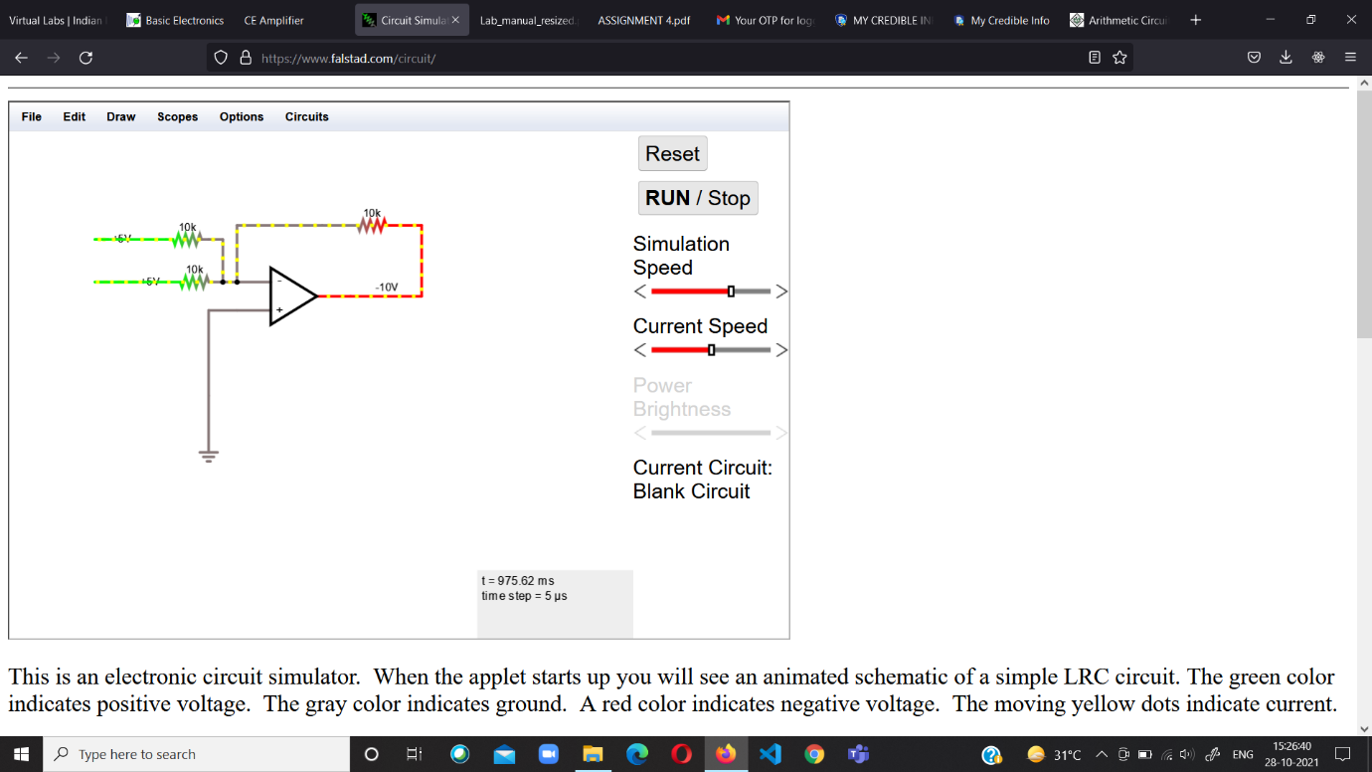

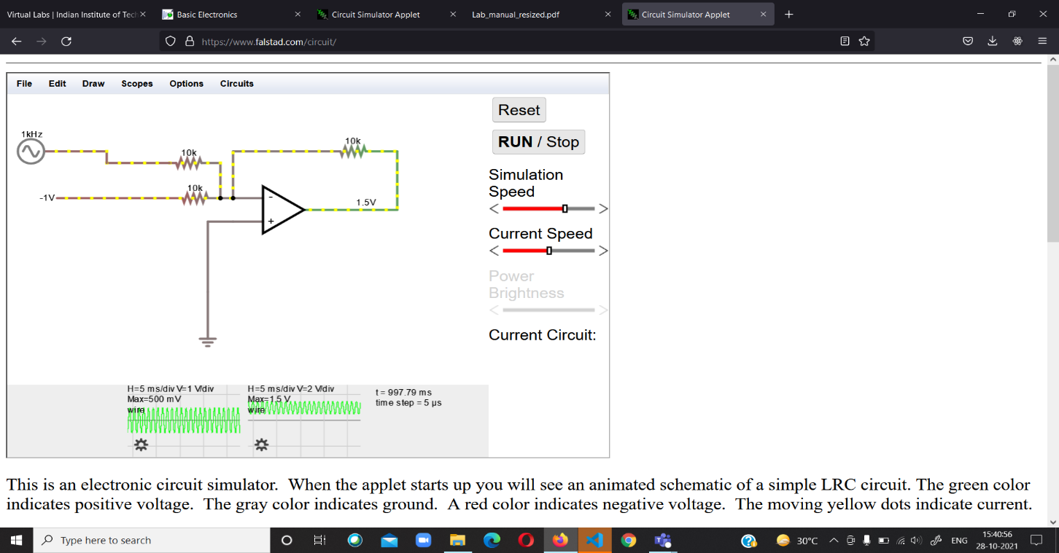

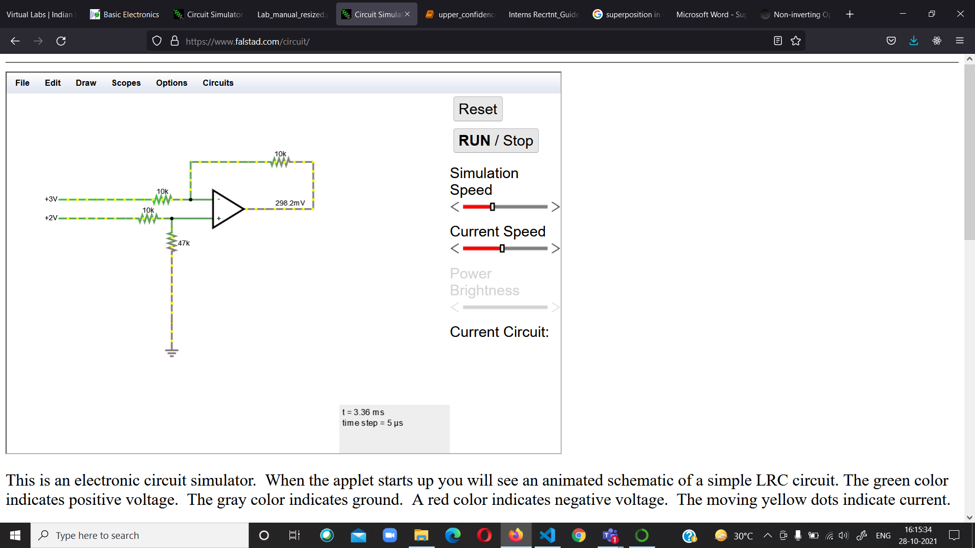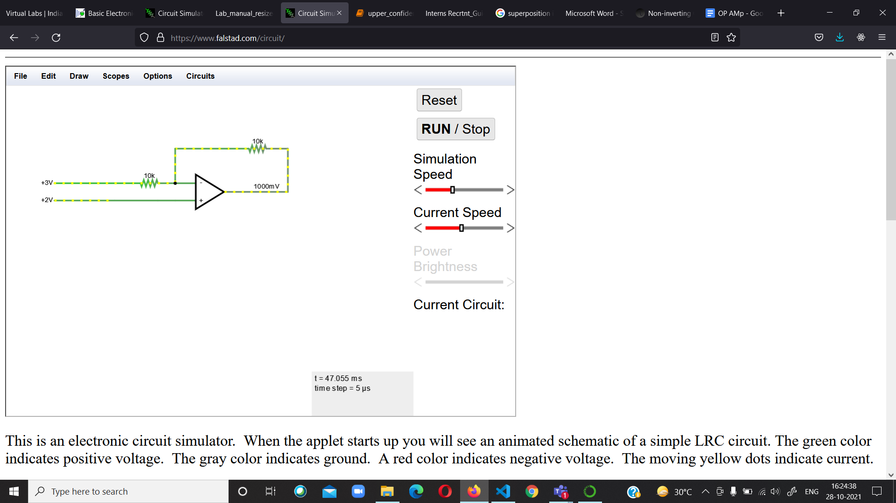

SUPERPOSITION